**How I cleared the AWS Security Specialty exam in 12 days in 2025**

Tips and Tricks to pass the AWS Certified Security — Specialty SCS-C02 Exam

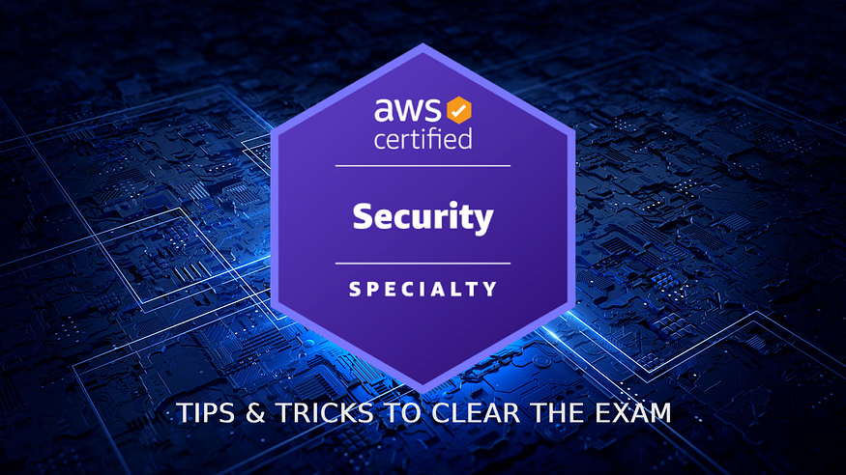

Clearing the AWS Certified Security Specialty SCS-C02 Exam (picture by author)

*“The only thing worse than starting something and failing… is not starting something.” —****Seth Godin***

*“I knew that if I failed I wouldn’t regret that, but I knew the one thing I might regret is not trying.” —****Jeff Bezos***

First and foremost, I give glory to my Lord and Savior Jesus Christ for blessing me with the ability to pass this challenging certification exam. His guidance and grace made this achievement possible. 🙏

After over 16 years of hands-on experience with AWS services both personally and professionally, I decided to challenge myself: Could I clear the AWS Security Specialty exam without investing in paid courses and spending too much time studying?

While I acknowledge this approach might not work for everyone, the strategy and tips I’m sharing can be valuable for anyone preparing for this certification.

**One important recommendation**: I strongly suggest taking the exam at a certification center instead of online. While online testing offers convenience, a certification center provides a controlled environment where technical issues and interruptions are less likely to happen during this important exam.

**Table of Contents**

1. [About the AWS Certified Security — Specialty Exam](https://medium.com/@rogernem/how-i-cleared-the-aws-security-specialty-exam-in-12-days-in-2025-dd63c5f1f9bd#9009)
2. [Week 1 (Starting May 26, 2025)](https://medium.com/@rogernem/how-i-cleared-the-aws-security-specialty-exam-in-12-days-in-2025-dd63c5f1f9bd#11a7)  
   1.1 [Day 1: Taking Action](https://medium.com/@rogernem/how-i-cleared-the-aws-security-specialty-exam-in-12-days-in-2025-dd63c5f1f9bd#3545)  
   1.2 [Days 2–6: Documentation Deep-Dive](https://medium.com/@rogernem/how-i-cleared-the-aws-security-specialty-exam-in-12-days-in-2025-dd63c5f1f9bd#818a)  
   1.3 [Day 7: Rest day](https://medium.com/@rogernem/how-i-cleared-the-aws-security-specialty-exam-in-12-days-in-2025-dd63c5f1f9bd#bb77)
3. [Week 2 (June 2, 2025)](https://medium.com/@rogernem/how-i-cleared-the-aws-security-specialty-exam-in-12-days-in-2025-dd63c5f1f9bd#e038)  
   2.1 [Days 8–10: FAQ Focus](https://medium.com/@rogernem/how-i-cleared-the-aws-security-specialty-exam-in-12-days-in-2025-dd63c5f1f9bd#502c)  
   2.2 [Day 11: Practice Questions](https://medium.com/@rogernem/how-i-cleared-the-aws-security-specialty-exam-in-12-days-in-2025-dd63c5f1f9bd#49ac)  
   2.3 [Day 12: Full Practice Exam](https://medium.com/@rogernem/how-i-cleared-the-aws-security-specialty-exam-in-12-days-in-2025-dd63c5f1f9bd#789e)  
   2.4 [Day 13: Gap Analysis](https://medium.com/@rogernem/how-i-cleared-the-aws-security-specialty-exam-in-12-days-in-2025-dd63c5f1f9bd#27c9)  
   2.5 [Day 14: Final Rest Day](https://medium.com/@rogernem/how-i-cleared-the-aws-security-specialty-exam-in-12-days-in-2025-dd63c5f1f9bd#ed5b)
4. [AWS Services Mapping by Exam Domain](https://medium.com/@rogernem/how-i-cleared-the-aws-security-specialty-exam-in-12-days-in-2025-dd63c5f1f9bd#0dce)
5. [Exam Day & Results (June 10, 2025)](https://medium.com/@rogernem/how-i-cleared-the-aws-security-specialty-exam-in-12-days-in-2025-dd63c5f1f9bd#06e4)
6. [Key Takeaways](https://medium.com/@rogernem/how-i-cleared-the-aws-security-specialty-exam-in-12-days-in-2025-dd63c5f1f9bd#e77d)
7. [Conclusion](https://medium.com/@rogernem/how-i-cleared-the-aws-security-specialty-exam-in-12-days-in-2025-dd63c5f1f9bd#98f9)

**About the AWS Certified Security — Specialty Exam**

AWS Certified Security — Specialty exam validates your expertise in creating and implementing security solutions in the AWS Cloud. This certification also validates your understanding of specialized data classifications and AWS data protection mechanisms; data-encryption methods and AWS mechanisms to implement them; and secure internet protocols and AWS mechanisms to implement them.

This exam consists of **65 questions**, with a minimum **passing score of 750** out of 1,000. It’s important to note that out of these 65 questions, only 50 questions affect your score, while 15 are unscored questions used by AWS to evaluate potential future exam content.

These unscored questions are not identified during the exam. The exam uses a compensatory scoring model, which means you need to pass the overall exam rather than individual sections.

The exam has the following content domains and weightings:

* **Domain 1: Threat Detection and Incident Response** (14%) — Identifying and mitigating security threats in AWS.
* **Domain 2: Security Logging and Monitoring** (18%) — Implementing logging solutions and monitoring AWS environments.
* **Domain 3: Infrastructure Security**(20%) — Securing networks, workloads, and compute services.
* **Domain 4: Identity and Access Management**(16%)**—**Configuring IAM policies, permissions, and access control.
* **Domain 5: Data Protection** (18%) — Ensuring encryption, key management, and secure data storage.
* **Domain 6: Management and Security Governance** (14%) — Aligning AWS security with compliance and governance standards.

This certification is valid for 3 years, after which you must recertify by taking the latest version of the exam.

**Week 1 (Starting May 26, 2025)**

The key to my success was creating a **structured plan with a clear goal**. Here’s how I did it:

**Day 1: Taking Action**

* Made the commitment by [booking my exam](https://www.aws.training/certification/?scs=sec&sec=overview) at a Pearson VUE certification center (300 USD. Visit [Exam pricing](https://aws.amazon.com/certification/policies/before-testing/#Exam_pricing) for additional cost information, including foreign exchange rates)
* Deep-dive into the [exam guide and scope](https://d1.awsstatic.com/onedam/marketing-channels/website/aws/en_US/certification/approved/pdfs/docs-security-spec/AWS-Certified-Security-Specialty_Exam-Guide.pdf)
* Mapped exam domains to specific AWS services
* Created a detailed study plan

**Days 2–6: Documentation Deep-Dive**

* Methodically reviewed AWS documentation for relevant services
* Leveraged my existing knowledge while paying extra attention to less-familiar services
* Focused on security-specific features and best practices

**Day 7: Rest day**

* Essential for information retention

**Week 2 (June 2, 2025)**

**Days 8–10: FAQ Focus**

* Thoroughly reviewed service FAQs
* Concentrated on security-related scenarios and solutions

**Day 11: Practice Questions**

* Attempted the [Official Practice Exam](https://skillbuilder.aws/learn/GBM5UWBB17/official-practice-exam-aws-certified-security--specialty-scsc02--english/11T3Z225UB) — Scored 19/20

**Day 12: Full Practice Exam**

* Took the [Official Practice Exam](https://skillbuilder.aws/learn/76W8UXTR4U/official-practice-question-set-aws-certified-security--specialty-scsc02--english/THWYAFSKED) — Scored 57/65  
  boosted confidence but room for improvement

**Day 13: Gap Analysis**

* Reviewed incorrect answers
* Strengthened weak areas
* Consolidated notes

**Day 14: Final Rest Day**

* Early to bed to ensure peak performance

**AWS Services Mapping by Exam Domain**

* **Domain 1:**AWS Security Hub, Amazon Macie, Amazon GuardDuty, Amazon Inspector, AWS Config, Amazon Detective, IAM Access Analyzer, Lambda, Step Functions, EventBridge, Systems Manager, Secrets Manager, S3, Athena, EBS
* **Domain 2:**CloudWatch, EventBridge, Lambda, SNS, Security Hub, GuardDuty, Systems Manager, VPC Flow Logs, DNS logs, CloudTrail, CloudWatch Logs, Athena
* **Domain 3:**AWS WAF, Elastic Load Balancers, Route 53, CloudFront, AWS Shield, Transit Gateway, VPC endpoints, Network Firewall, AWS VPN, Direct Connect, Amazon Inspector, Amazon ECR, EC2 Image Builder, Systems Manager Session Manager, Traffic Mirroring
* **Domain 4:**IAM, IAM Identity Center (AWS Single Sign-On), Amazon Cognito, AWS STS, Directory Service, CloudTrail, IAM Access Advisor, IAM policy simulator
* **Domain 5:**Direct Connect, VPN gateways, RDS, Redshift, CloudFront, S3, DynamoDB, Elastic Load Balancers, EFS, API Gateway, Systems Manager, EC2 Instance Connect, KMS, CloudHSM, AWS Backup
* **Domain 6:**AWS Organizations, Control Tower, Service Catalog, Firewall Manager, AWS RAM, AWS Config, Macie, Security Hub, Audit Manager, Trusted Advisor, Cost Explorer, AWS Well-Architected Tool

**Exam Day & Results (June 10, 2025)**

Arrived fresh and focused at the testing center in the morning, ready to tackle the challenge.

The examination proved more challenging than anticipated, particularly due to the complexity and length of both questions and answer choices, where subtle differences in terminology often played a crucial role

With 170 minutes to complete 65 questions, I followed a strategic approach:

* Carefully analyzed questions containing key terms such as “most secure,” “cost effective”, “best practice,” and “least privilege,” as these often point to the correct answer.
* Used process of elimination to systematically identify the best solution when faced with multiple plausible options.
* Managed time by allocating approximately 2.4 minutes per question, reserving 15 minutes at the end for reviewing marked questions and final submission.

After completing the exam, I returned to work, eagerly anticipating the results. While AWS indicates that certification results can take up to five business days to process, I was pleasantly surprised to receive my results in less than 24 hours.

Opening that email brought immense joy and gratitude as I learned that I had successfully passed the AWS Security Specialty certification. First and foremost, I give thanks to God for this achievement.

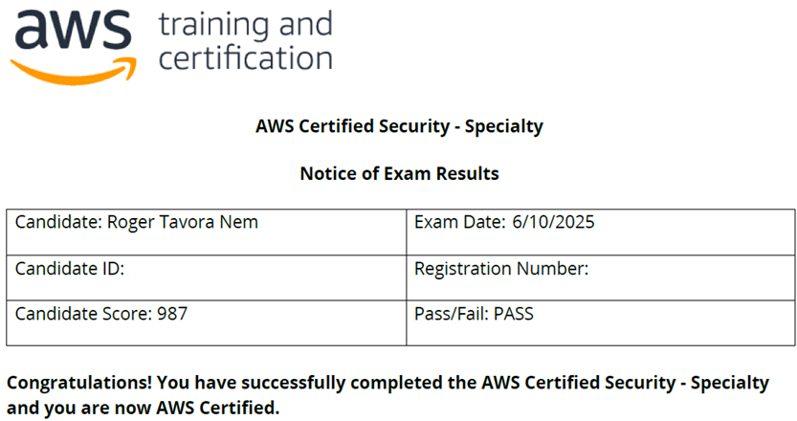

AWS Certified Security — Specialty Exam results 🙏🙌😀

**Verify my Badge here:**[https://www.credly.com/badges/b4ab1991-6886-4572-9318-d2699d1d160a](https://www.credly.com/badges/b4ab1991-6886-4572-9318-d2699d1d160a/public_url)

**Key Takeaways**

1. Having a structured study plan is crucial
2. Leverage official AWS documentation
3. Practice tests are very helpful
4. Don’t underestimate the importance of rest
5. Real-world experience/hands-on is a significant advantage

**Conclusion**

Remember, while my timeline was aggressive, the fundamental approach can be adapted to any preparation schedule. The key is to remain focused, organized, and committed to your goal.

To those preparing for the AWS Security Specialty exam, I wish you the very best in your certification journey. While achieving certification is a valuable goal, remember that the true value lies in the knowledge and understanding you gain throughout your preparation process. The security landscape is ever-evolving, and this learning will serve you well beyond the exam day.

Happy learning and good luck!

**If you enjoyed this article and found it helpful, please don’t forget to leave a heart**❤**, comment**💬**, clap**👏🏻**, and share**➦ **it to show your support.**

**Also, don’t forget to**[**connect**](https://www.linkedin.com/in/rogertn/)**,**[**follow me**](https://medium.com/@rogernem)**for more articles and support me by**[buying me a coffee](https://buymeacoffee.com/rogernem)**.**:-)**Thank you!**

References:  
- <https://www.aws.training/certification/?scs=sec&sec=overview>  
- <https://d1.awsstatic.com/onedam/marketing-channels/website/aws/en_US/certification/approved/pdfs/docs-security-spec/AWS-Certified-Security-Specialty_Exam-Guide.pdf>  
- <https://skillbuilder.aws/learn/GBM5UWBB17/official-practice-exam-aws-certified-security--specialty-scsc02--english/11T3Z225UB>  
- <https://skillbuilder.aws/learn/76W8UXTR4U/official-practice-question-set-aws-certified-security--specialty-scsc02--english/THWYAFSKED>